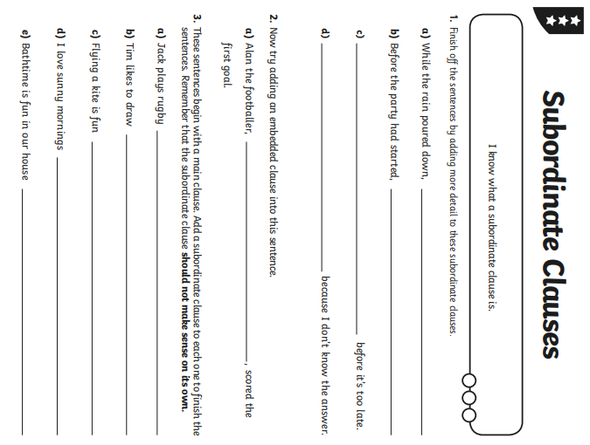

**Hint**: Subordinate clauses start with subordinate conjunctions (I SAW A WABUB)

If, Since, As, While, After, When, Although, Because, Until, Before

