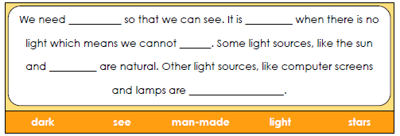

**How many light sources around your home can you find? List each one in the table below. When you have done that, think of other light sources you might see in other places inside or outdoors. List as many as you can in the other light sources column**

|  |  |
| --- | --- |
| **Light Sources in the home** | **Other light sources** |
|  |  |

Complete paragraph below: